

Academic Skills and Team-based Learning (4CIO18)

Final portfolio project <Individual Task>

Student Id: np03cs4s230229

Student Name: Aakriti khatri k.c

Group: <L4CG3>

Lecturer: Mr. Manish Deuja Tutor: Phurba Yangji Sherpa

**Acknowledgment.**

Respected teacher as well as my friends I wolud like to give thank for their invaluable support and guidance during the initial stages of this project. Both of professors have provided me with constructive feedback and encouragement, which has been very useful for the overall quality of this report. However, I would like thank some of my classmates for helping me understand the format and guides me.

# Abstract

The portfolio of academic skills contains a complete collection of materials representing Report 8 and 11, presentation slides, graduation form, blog links, video statements links, CV, and cover letter. This portfolio provides a holistic view of my academic accomplishments, professional growth, and skills acquired throughout my educational journey. This module highlights a wide variety of materials that demonstrate my academic achievements, communication skills, and preparedness for future opportunities which reflects my dedication, passion, and growth in the academic field, serving as evidence of my abilities and potential for future success.

## Contents

1. **Link to Blogs** ........................................................................................................................... 1
2. **video statement link** .............................................................................................................. 1
3. **Academic report Week 8** ...................................................................................................... 2
   1. **Introduction:** .................................................................................................................... 2
      1. **University of Wolverhampton:** .................................................................................. 2
      2. **Herald college kathmandu:** ........................................................................................ 3
      3. **Introduction of F1 soft company:** ............................................................................ 4
      4. **Tribhuvan university:** ................................................................................................. 5

**3.2.1Findings** ............................................................................................................................... 6

### 3.2.2. Courses provided by Herald College Kathmandu: ............................................ 7

**3.2.3. Comparison between university of Wolverhampton and Tribhuvan university** .................................................................................................................................. 8

**3.3. Conclusion:** ...................................................................................................................... 9

1. **Professionalism Task/Employability Task** .................................................................... 10
   1. **CV** ...................................................................................................................................... 10
   2. **Cover Letter** ................................................................................................................... 11
   3. **Graduate Form** .............................................................................................................. 13
2. **Artificial Intelligence (AI)** ................................................................................................... 19
3. **The Professional Organizational Report** ....................................................................... 20
   1. **Introduction** .................................................................................................................... 20
   2. **The Body** ........................................................................................................................ 21

### 6.2.1 To be the member of British Computer Society (BCS) has several advantages. Here are some of the main advantages. ................................................ 23

**6.2.2. Disadvantages of (BCS):** ......................................................................................... 25

**6.3. Conclusion:** .................................................................................................................... 26

References ..................................................................................................................................... 27

**7. The Presentation slides of our group;** ........................................................................... 28

Figure 1 University of Wolverhampton; ......................................................................................... 2

[Figure 2University of Wolverhampton; ........................................................................................... 2](https://livewlvac-my.sharepoint.com/personal/a_khatri7_wlv_ac_uk/Documents/aakrityy%20final%20portfolio.docx#_Toc135250101)

Figure 3 Herald College Kathmandu;............................................................................................... 3

[Figure 4 FIG of HCK; ........................................................................................................................ 3](https://livewlvac-my.sharepoint.com/personal/a_khatri7_wlv_ac_uk/Documents/aakrityy%20final%20portfolio.docx#_Toc135250103)

Figure 5 fig of F1 Soft Company; ..................................................................................................... 4

Figure 6 fig of Tribhuvan University of Kathmandu,Nepal .............................................................. 5

[Figure 7 Fig of F1Soft; ...................................................................................................................... 6](https://livewlvac-my.sharepoint.com/personal/a_khatri7_wlv_ac_uk/Documents/aakrityy%20final%20portfolio.docx#_Toc135250106)

Figure 8 courses provide by HCK; .................................................................................................... 7

Figure 9 screenshot of cv; ............................................................................................................. 10

Figure 10 graduation form; ........................................................................................................... 13

[Figure 11 Fig of British Computer Society ..................................................................................... 20](https://livewlvac-my.sharepoint.com/personal/a_khatri7_wlv_ac_uk/Documents/aakrityy%20final%20portfolio.docx#_Toc135250110)

[Figure 12 fig of BCS ....................................................................................................................... 20](https://livewlvac-my.sharepoint.com/personal/a_khatri7_wlv_ac_uk/Documents/aakrityy%20final%20portfolio.docx#_Toc135250111)

Figure 13 fig of employer; ............................................................................................................. 21

Figure 14 fig of Advantages; .......................................................................................................... 23

Figure 15 Fig of Disadvantages; ..................................................................................................... 25

Figure 16 web developments slide; .............................................................................................. 28

Figure 17 Agenda Slide; ................................................................................................................. 28

Figure 18 Introduction Slide; ......................................................................................................... 29

Figure 19 History Slide; ................................................................................................................. 29

Figure 20 Process slides; ............................................................................................................... 30

Figure 21 Types Slide; .................................................................................................................... 30

Figure 22 Advantages Slide; .......................................................................................................... 31

Figure 23 Disadvantages Slides; .................................................................................................... 31

Figure 24 Conclusion Slides; .......................................................................................................... 32 Figure 25 References Slide; ........................................................................................................... 32

**1 Blogs link.**

* <https://aakritikhatrikc.wordpress.com/2023/03/01/first-day-at-herald-college/>
* <https://aakritikhatrikc.wordpress.com/2023/03/14/my-blog/>
* [https://aakritikhatrikc.wordpress.com/2023/03/15/experience-at-herlad-collegekathmandu-week-third/](https://aakritikhatrikc.wordpress.com/2023/03/15/experience-at-herlad-college-kathmandu-week-third/)
* [https://aakritikhatrikc.wordpress.com/2023/03/27/week-4-blog-at-herald-collegekathmandu/](https://aakritikhatrikc.wordpress.com/2023/03/27/week-4-blog-at-herald-college-kathmandu/)
* [https://aakritikhatrikc.wordpress.com/2023/03/31/week-5-blog-at-herald-collegekathmandu/](https://aakritikhatrikc.wordpress.com/2023/03/31/week-5-blog-at-herald-college-kathmandu/)
* [https://aakritikhatrikc.wordpress.com/2023/04/13/week-6-at-herald-collegekathmandu/](https://aakritikhatrikc.wordpress.com/2023/04/13/week-6-at-herald-college-kathmandu/)
* [https://aakritikhatrikc.wordpress.com/2023/04/15/week-7-at-herald-collegekathmandu/](https://aakritikhatrikc.wordpress.com/2023/04/15/week-7-at-herald-college-kathmandu/)
* [https://aakritikhatrikc.wordpress.com/2023/04/23/week-8-at-herald-collegekathmandu/](https://aakritikhatrikc.wordpress.com/2023/04/23/week-8-at-herald-college-kathmandu/)
* <https://aakritikhatrikc.wordpress.com/2023/04/27/week-9-blog/>
* [https://aakritikhatrikc.wordpress.com/2023/05/07/week-10-at-herald-collegekathmandu/](https://aakritikhatrikc.wordpress.com/2023/05/07/week-10-at-herald-college-kathmandu/)
* <https://aakritikhatrikc.wordpress.com/2023/05/17/week-11-at-herald-college/>
* [https://aakritikhatrikc.wordpress.com/2023/05/17/week-12-blog-at-herald-collegekathmandu/](https://aakritikhatrikc.wordpress.com/2023/05/17/week-12-blog-at-herald-college-kathmandu/)

### 2. video statement link

➢ https://drive.google.com/file/d/1TfmVT_uLSfhIUsL0Ts6CETF2DOQgBGP/view?usp=sharing

### 3. Academic report Week 8

**3.1. Introduction:**

**3.1.1 University of Wolverhampton:**



*Figure 1 University of Wolverhampton;*



The University of Wolverhampton was founded in 1835 as an institute. But gained university status in 1992. The University of Wolverhampton is respected all over the world which give different course in academic firings and a strong commitment to research and have a strong reputation, enterprises, and

*Figure 2University of Wolverhampton;* innovation links with industries. The University of

Wolverhampton provides high quality teaching and learning while receiving numerous awards for its academic programs. This universities four campus are spread across Wolverhampton, Telford, and walsall to support the student academics and personal development. However, this university focuses on the growth of students for the better result in their career. (university of

wolverhampton, 2023)

**3.1.2 Herald college kathmandu:**



*Figure 3 Herald College Kathmandu;*

 Herald college is a well- known college which was established in 2010 and is realtedwith the Wolverhampton and the marks are equivalent to Tribhuvanuniversity.

Herald college kathmandu provides the globally recognized degree from the university of Wolverhampton with the best as facilities in very reasonable price. Herald collegekathmandu is providing different skills from different course like BIT, Bibm, IMBA. There is different way to teacch In Herald like

Lecture,tutor, and workshop *Figure 4 FIG of HCK;*

everyweek. (Herald college Kathmandu, 2023)

**3.1.3 Introduction of F1 soft company:**

 *Figure 5 fig of F1 Soft Company;*

F1 Soft International is a top Nepalese information technology company that specializes in offering digital payment services and software solutions to various businesses and organizations. In 2004, this company is well developed in technology field in different sector by emphasizing both innovation and customer satisfaction. The software solutions offered by F1 are Core banking software, mobile banking software, digital wallets, and online payment gateways. The products of this company are intended to assist businesses of all sizes, financial institutions, and banks in streamlining and increasing efficiency. However, F1 Soft International is a leading Nepalese information technology company that offers businesses and organizations cutting-edge software solutions and digital payment services which built a solid reputation in the industry, both in Nepal and internationally, thanks to its dedication to excellence and customer satisfaction. (F1Soft International company, 2023)

**3.1.4. Tribhuvan university:**

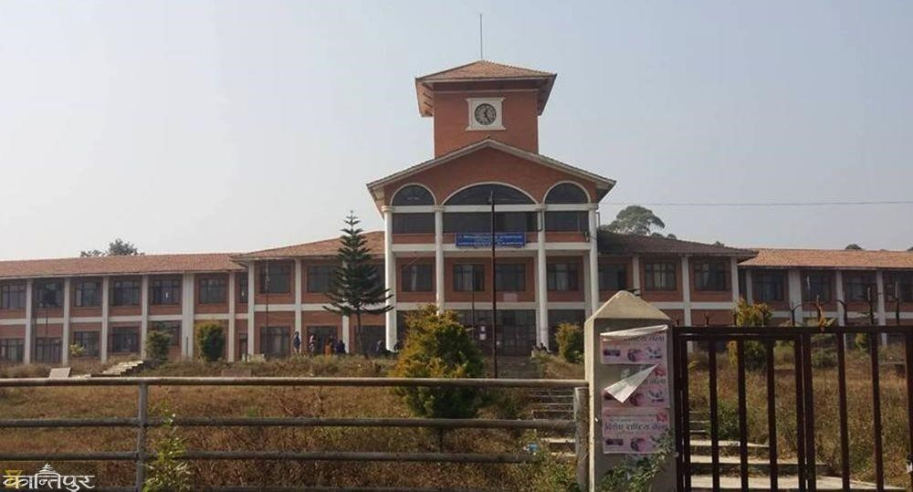

*Figure 6 fig of Tribhuvan University of Kathmandu,Nepal*

Tribhuvan university (TU) is a local university of Nepal, which is in kritipur, kathmandu. This was established in 1958 as the first national university of higher education in Nepal. Tribhuvan university offers degrees in various courses such as arts, management, engineering, law. TU has a diverse student community from various ethnic, cultural, and socioeconomic backgrounds which provides a very supportive and inclusive learning environment that motivates students to learn . There are several students’ clubs and organizations that provide opportunities for students to participate in extracurricular activities and develop their skills and interests. Overall, Tribhuvan is top college in Nepal, which provides a world-class education to its students and contributing to the country’s development through research and innovation with its committed to academic excellence, diversity, and inclusivity has made it a premier institution in the region and an inspiration for universities around the world. (Tribhuwan University, 2023)

### 3.2.1Findings

After so much research about the university courses and the skills that Wolverhampton provide and the f1 soft company, I have found the following:

- Why to Hire students of Herald.



F1 soft is a Nepalese technology company thatis limited in providing software solutions and digital services to various industries such as banking, financial services, and insurance. It has become one of the leading software development companies in Nepal with the range of software products that *Figure 7 Fig of F1Soft;* meets the needs of financial industry which includes mobile banking, online payments, core banking and insurance management system. The product arrangements, F1 Delicate Global

additionally gives computerized installment administration through its auxiliary. Esewa is a famous computerized wallet in Nepal that permits clients to make online installments, take care of bills, and move cash to different clients. F1 soft places a strong emphasis on customer satisfaction. This company is committed to innovation and continuously looks for ways to improve its products and services. F1 soft always invest heavily in research and development to stay ahead of the curve and provide up-to-date solutions to the clients. F1 soft has built a strong reputation as a reliable and trusted partner in the software development industry. Overall, hiring the graduates of university of Wolverhampton with skilled based knowledge can provides the company with access to valuable requirnment, expertise, and chances, helping them to stay competitive and innovative in their respective industries.

**3.2.2. couse of Herald college.**

Course of Wolverhampton offers a range of courses with disciplines, skills, knowledge, and the confidence to build a better career for students. The university of Wolverhampton have a best range of facilities for students in every sector, including libraries (place to run students mind in books), computer lab (with 24/7 Wi-Fi), comfortable bench, sport (volleyball, football, basketball, badminton, table tennis). However, the Herald college kathmandu (HCK) is a dynamic and forward-thinking institution in Nepal with a wide range of academic program, services, and research opportunity to achieve academic and personal goal. The course structure are given below:

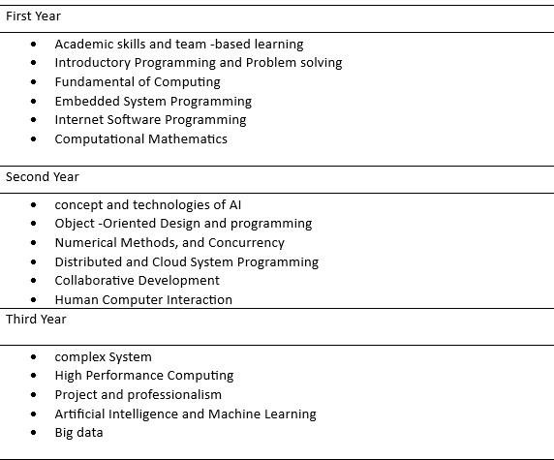

*Figure 8 courses provide by HCK;*

**3.2.3. Comparison between university of Wolverhampton and Tribhuvan university**

There are more than enough distinc between them because the University of Wolverhampton is a university in a better settled country than Tribhuvan university. Both universities share the difference of education pattern and so on. With my research I have described the differences below:

#### i. Teaching Method

The teaching method of both universities is very differed from each other. The university of Wolverhampton focus on the teaching approach to teaching with Lecture, tutorial, and workshop (LTW)way whereas the Tribhuvan university teaches their students in a traditional way which is more based on the lecture learning and greater emphasis on rote learning. However, both universities aim to provide quality education which helps students to develop their thinking capacity develop and problem-solving skills .

#### ii. Tuition Fee

In terms of tuition fees, Tribhuvan university is cheaper than university of Wolverhampton. The tuition fee of Tribhuvan is counted in rupees whereas university of Wolverhampton’s tuition fee counted in pounds.

##### iii. languages of teaching

As Tribhuvan university teaches the students on both English and Nepali language (mother language of Nepal) but focus more on Nepali languages to teach whereas university of Wolverhampton only teaches students in English language.

##### iv. Campus Facilities

The university of Wolverhampton has huge range of facilities including libraries, laborites, sports, accommodation, health facilities, to fulfill the comfort of students whereas in Tribhuvan university has more traditional facilities, low facilities in every sector and the building are old.

#### v. Diverse Community Students

The university from Wolverhampton has many students who are becoming members as students from different countries and a good mix of ethnicities and culture whereas Tribhuvan universities have students from their own country. (Herald college Kathmandu, 2023)

**3.3. Conclusion:**

In conclusion, the university of Wolverhampton and Tribhuvan university are two vastly different higher education institutions. The university of Wolverhampton is a modern and skilled based university whereas the Tribhuvan university is the oldest and largest university in Nepal, which only focus on the traditional academic disciplines. Both universities have their own strengths and weaknesses, but the goal of both universities is the same, to give quality skills to secure the students’ future with Information Technology (IT). Overall, the university of Wolverhampton and Tribhuvan university have their own unique characteristics and qualities. It also helps the company to raise skills in different fields.

### 4. Professionalism Task/Employability Task

**4.1 CV**

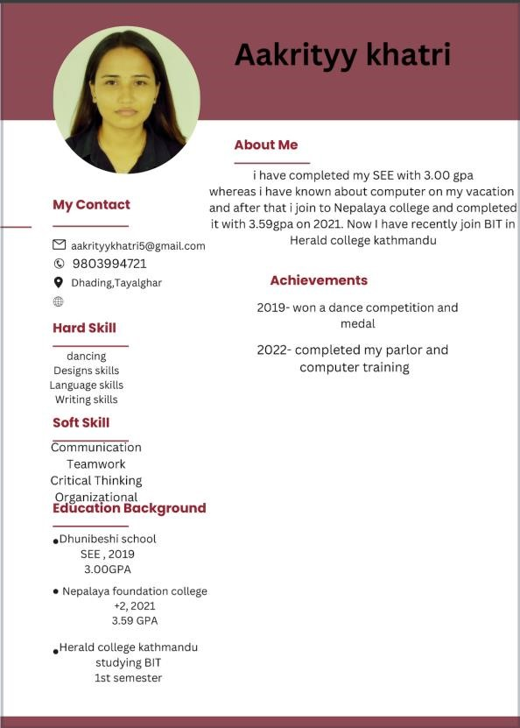

*Figure 9 screenshot of cv;*

**4.2. Cover Letter**

AAKRITI KHATRI K.C.

Dhading, Tayalghar | 977+ 9803994721 | aakrityykhatri5@gmail.com

**19th March 2023**

GYANENDRA BAHADUR KARKI

GRAPHICS DESIGNER

F1 SOFT NEPAL

Koteshwor, Kathmandu NEPAL GPO Box: 8975 EPC 2626

**Dear GYANENDRA BAHADUR KARKI:**

I am very passionate to put in an application for the Graphic Designer post at F1 Soft Nepal with my passion for design and experience in graphic design and optimistic that I will make a valuable addition to your team.

As a graphic designer, I have worked on lots of works like project, including branding, marketing collateral, and web design. I have expertise in Adobe Creative Suite and a deep understanding of design principles and attention to detail have allowed me to deliver high-quality work that exceeds expectations. I have strong teamwork skills and can communicate clearly and manage my time efficiently. These skills have been very helpful in creating designs that are visually attractive and captivating. I am excited to apply my skills to F1 Soft Nepal, a company that values innovation, creativity, and excellence. I am excited to work alongside like-minded individuals and contribute to the company's mission of delivering innovative solutions to the financial industry. I am versatile and capable of working effectively in a dynamic and fast paced setting, delivering projects on time even with stringent timelines while maintaining the quality of my work. However, I believe my passion for design, creativity, and technical expertise make me an ideal contender for this position.

Thank you for taking this into consideration. I look forward to the opportunity to contribute my skills and experience to F1 Soft Nepal.

Sincerely

AAKRITI KHATRI K.C.

**4.3. Graduate Form**

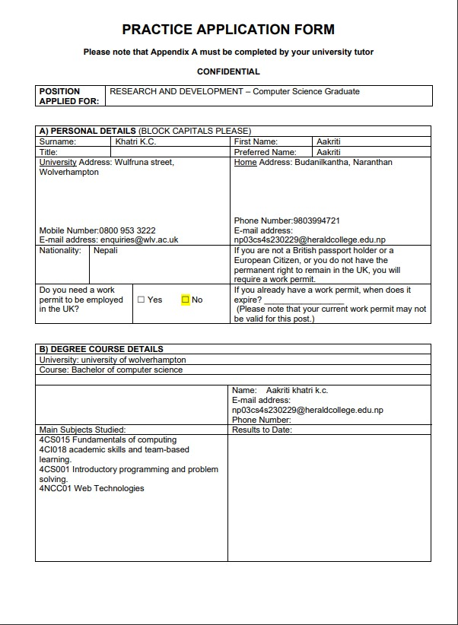

*Figure 10 graduation form;*

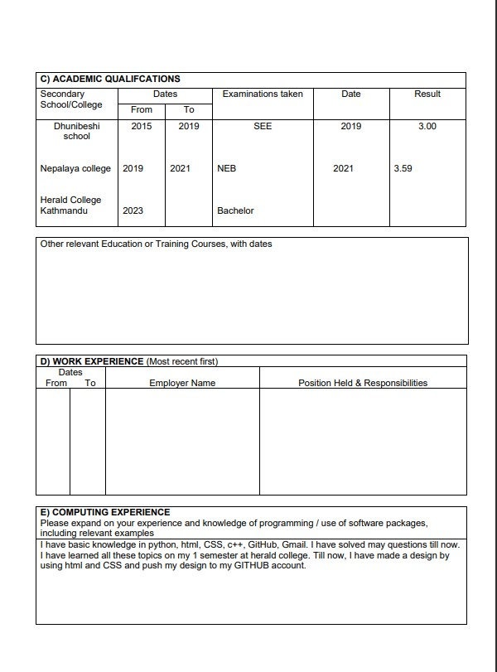

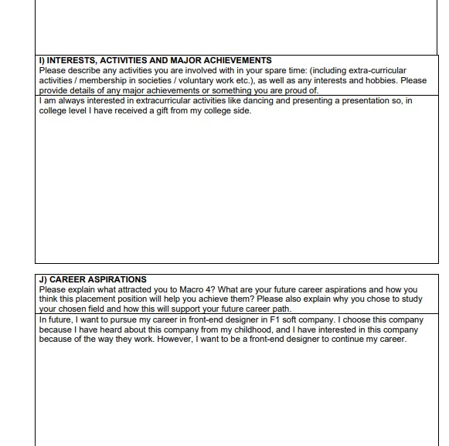

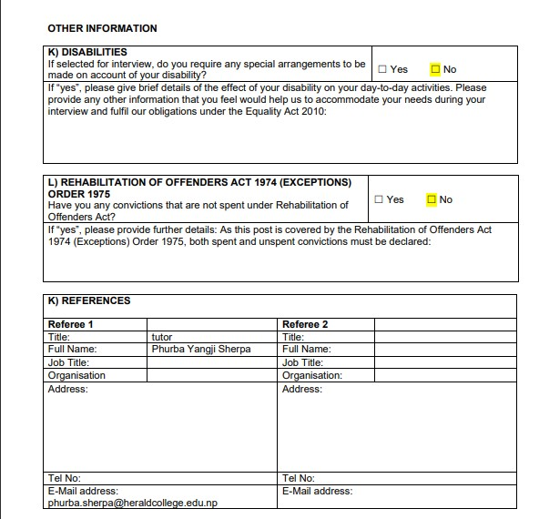



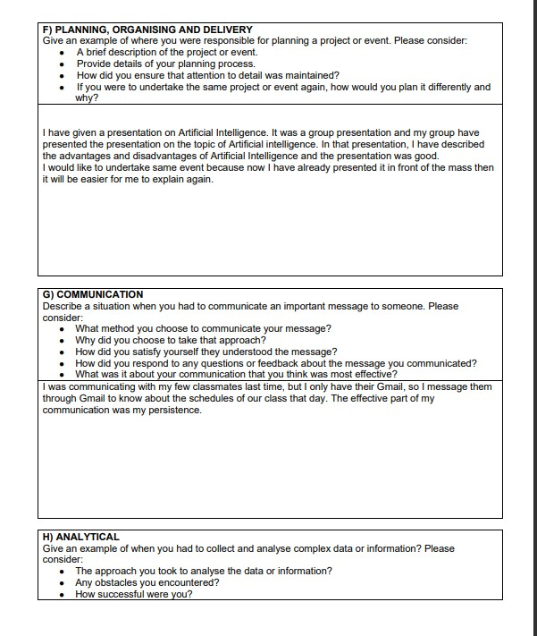

### 5. Artificial Intelligence (AI)

PROS OR ADVANTAGES OF ARTIFICIAL INTTELIGENCE. Artificial Intelligence (AI) has rapidly become a prominent technology in our modern world, and it is poised to transform nearly every aspect of our lives with the increasing use of AI in a field of computer science that focuses on creating machines capable of performing tasks that would normally require human intelligence. One of the most significant advantages of AI is that it can greatly improve efficiency. its algorithms can analyze vast amounts of data much faster and more accurately than humans can. By reducing the time and resources needed to perform tasks, AI can help organizations become more efficient and productive. AI is a rapidly growing field of computer science that focuses on creating machines and software programs capable of performing tasks that would typically require human intelligence. As AI technology continues to advance, it is expected to have an even greater impact on our society, opening new possibilities for innovation, efficiency, and productivity. In this article, we will explore some of the key benefits of AI, including improved efficiency, cost savings, personalization, accuracy, decision-making, safety, and innovation. It can help to analyze data and provide tailored recommendations to individual customers. For example, an online retailer can use AI to analyze a customer's browsing history and purchase behavior to suggest products they are more likely to buy. This can accelerate to sales and customer satisfaction. Implementing AI can help businesses save money in various ways. For example, AI can help automate routine tasks, reducing the need for human labor. In conclusion, AI has numerous benefits that make it a powerful tool for businesses and individuals alike. From improving efficiency and accuracy to increasing safety and driving innovation, it is poised to transform the way we live and work in the generation to come. (UN Women, 2023)

### 6. The Professional Organizational Report

**6.1. Introduction**

#### The British Computer Society (BCS)



*Figure 11 Fig of British Computer Society* The British

It is a professional body for computing professionals in the United Kingdom. It was founded in 1957 and is based in Swindon, Wiltshire. The BCS's mission is to enhance computers and provide professional development opportunities for its members. It is a membership-based organization, and its members come from a various backgrounds, including academics, IT professionals, and students. The BCS offers a range of professional qualifications, including certifications in areas such as project management, *Figure 12 fig of BCS*

software testing, and business analysis. BCS provides chances for learning and development to help people advance in their careers and increase levels of competence in our field. We analyze and recognize talent at all levels through a wide range of credentials, professional registrations, content, and skill frameworks. The British Computer Society plays an important role in promoting excellence in computing and leading the professional development of those working in the field. There are various membership levels available, including professional, affiliate, student, and retired. (British computer Society, 2023)

**6.2. The Body**

BCS is an organization in the United Kingdom for persons and businesses working in computers and associated technology. It provides the members with a variety of services, such as professional development, networking opportunities, and available to a variety of resources and programs.

 *Figure 13 fig of employer;*

**Here are the steps to become the member of British computer Security (BCS):**

* Determine your membership category: Visit the BCS website and review the membership categories to determine which one is appropriate for you. Consider your qualifications, experience, and career goals when selecting a category.
* Apply for membership: Once you have identified the appropriate membership category, you can apply for membership online by filling out an application form. You will need to provide personal and professional information, such as your qualifications, work experience, and current job title.
* Pay membership fees (if applicable): Depending on your membership category, you may need to pay an annual membership fee. Payment options include credit card, bank transfer, or direct debit.
* Wait for confirmation: After you have submitted your application and paid any applicable fees, the BCS will review your application and notify you of its decision. If your application is successful, you will receive a confirmation email with details about your membership.

The BCS provides a variety of volunteer options, including sitting on committees, mentoring students, and contributing to publications with possibilities of accessible to both members and nonmembers; however, preference is given to BCS members.

**6.2.1 To be the member of British Computer Society (BCS) has several advantages. Here are some of the main advantages.**



*Figure 14 fig of Advantages;*

* **Professional development:** The British Computer Society provides a variety of professional development options, including as training courses, events, and conferences. Members can use these tools to remain current on the latest trends and best practices in the world of computing.
* **Networking:** BCS membership provides opportunities for networking with other computing professionals, including access to online forums, special interest groups, and regional branches. This can be invaluable for building relationships, finding job opportunities, and staying connected with the broader computing community.
* **Career support**: BCS provides a maximum of resources to help members advance their careers, including job boards, career advice, and mentoring programs.
* **Use to resources:** BCS membership provides access to a wide range of computing resources, including publications, research, and databases. This can be particularly useful for those working in specialized areas of computing.
* **Influence:** BCS membership can be an asset for computing professionals looking to intensify their skills, build their networks, and advance their future in the field.

**6.2.2. Disadvantages of (BCS):**



*Figure 15 Fig of Disadvantages;*

* **Cost:** Membership fees can be a worthy expense, especially for those on a less budget. While the cost of BCS membership is generally considered to be reasonable, it may be difficult for some individuals to justify the expense.
* **Limited local presence:** While BCS has regional branches throughout the UK, its presence may be limited to certain region. This could make it hard for members to fully take advantage of networking and professional development opportunities.
* **Limited relevance for some members:** While BCS covers a broad range of computing topics, some members may find that the organization's focus is not directly relevant to their specific area of expertise. This could limit the value of membership for these individuals.
* **Limited recognition outside of the UK:** While it is a respected professional organization within the UK, its recognition may be more limited outside of the country. This could be a disadvantage for members who work in international contexts. However, it is important to precisely consider the costs and benefits of membership before planning.

**6.3. Conclusion:**

In conclusion, it is an executive organization for computing professionals in the United Kingdom. Founded in 1957, the BCS aims to promote excellence in computing and to carry the professional development of its members. BCS clientship provides surplus to a various of benefits, including professional development opportunities, networking, career support, and access to resources. These advantages can be particularly valuable for computing executives looking to remain up to date with the latest trends and best practices in the field. There are some potential drawbacks to BCS membership, such as cost and limited local presence, these are generally minor compared to the potential benefits. Overall, the BCS is an important organization for computing professionals in the UK, and its mission to promote excellence in computing and support the professional development of its members is an important one.

### References

(n.d.). Retrieved from university of wolverhamptom: https://www.wlv.ac.uk/

(n.d.). Retrieved from Herald college Kathmandu: https://heraldcollege.edu.np/

*British computer Society*. (2023, 05 04). Retrieved from https://www.bcs.org/

*F1Soft International company*. (2023, 05). Retrieved from https://f1soft.com/

*Herald college Kathmandu*. (2023, 01 20). Retrieved from https://heraldcollege.edu.np/

*Tribhuwan University*. (2023, 03 12). Retrieved from https://tu.edu.np/

*UN Women*. (2023, 14 05). Retrieved from https://www.unwomen.org/en/how-wework/innovation-and-technology/glossary?gclid=CjwKCAjw9pGjBhB-

EiwAa5jl3Lpkr3U67LMkKLQuaZ3vOw3A3BQH81U7DwSDd6_s4PYVs3GwKyoeZBoC3UsQ

AvD_BwE

*university of wolverhampton*. (2023, 01 23). Retrieved from https://www.wlv.ac.uk/

#### 7. The Presentation slides of our group;



*Figure 16 web developments slide;*



*Figure 17 Agenda Slide;*

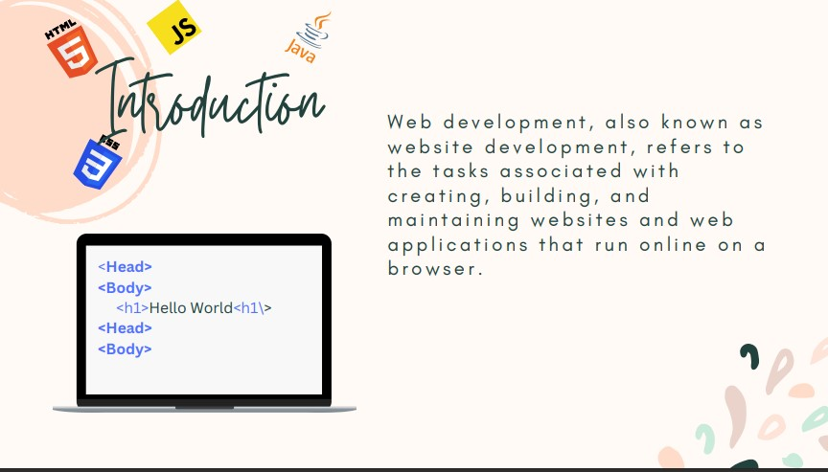 *Figure 18 Introduction Slide;*

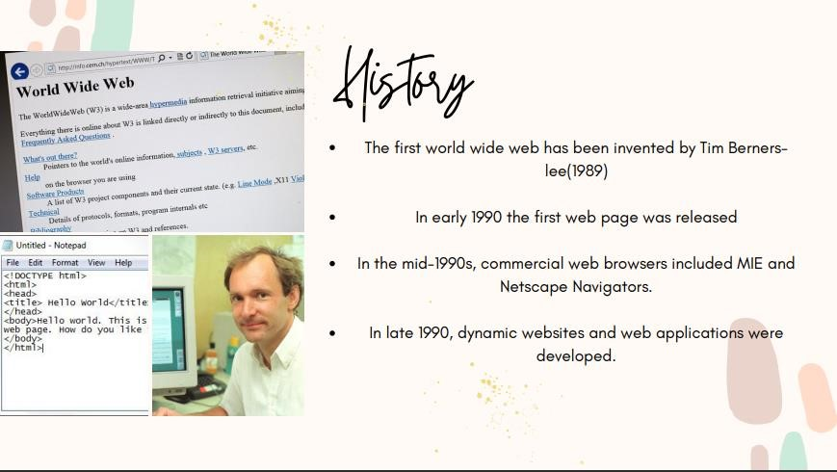 *19 History Slide;*

 *Figure 20 Process slides;*



*21 Types Slide;*

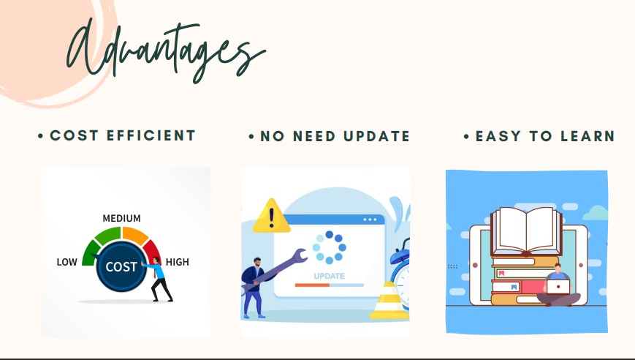

*Figure 22 Advantages Slide;*



*23 Disadvantages Slides;*

 *Figure 24 Conclusion Slides;*

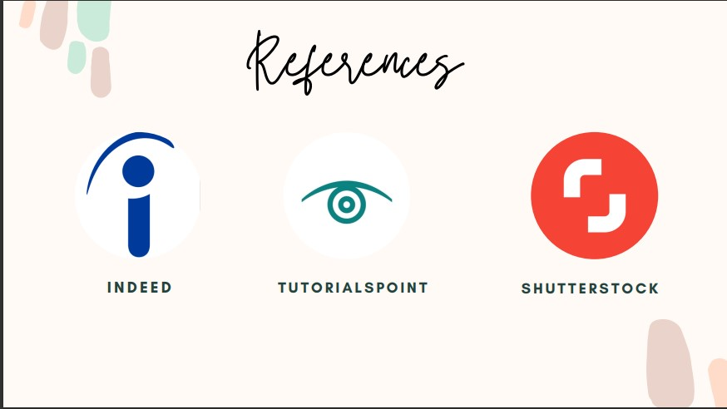 *Figure 25 References Slide;*